COMPUTER NETWORKS

**LAB EXPERIMENTS**

1. Configuration of Network Devices using Packet Tracer (Hub, Switch, Ethernet, Broadcast)

HUB & SWITCH

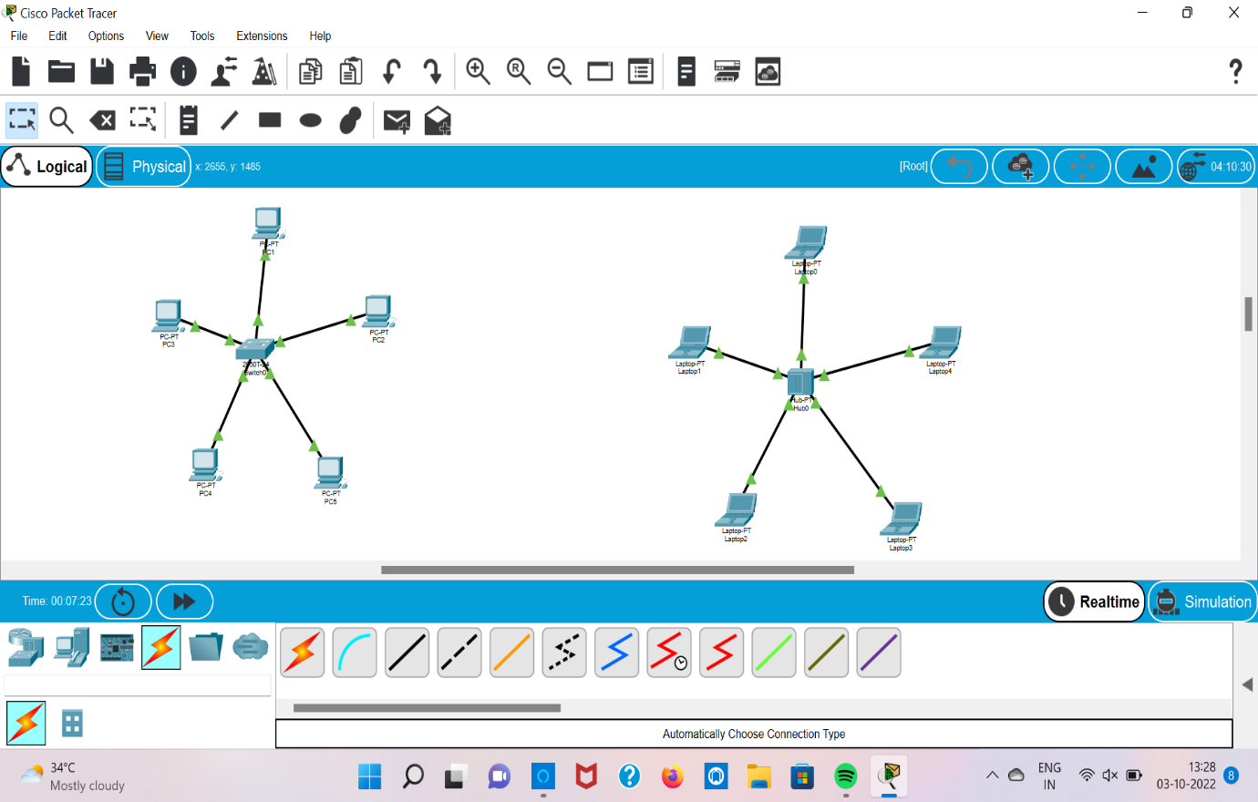

ETHERNET & BROADCAST

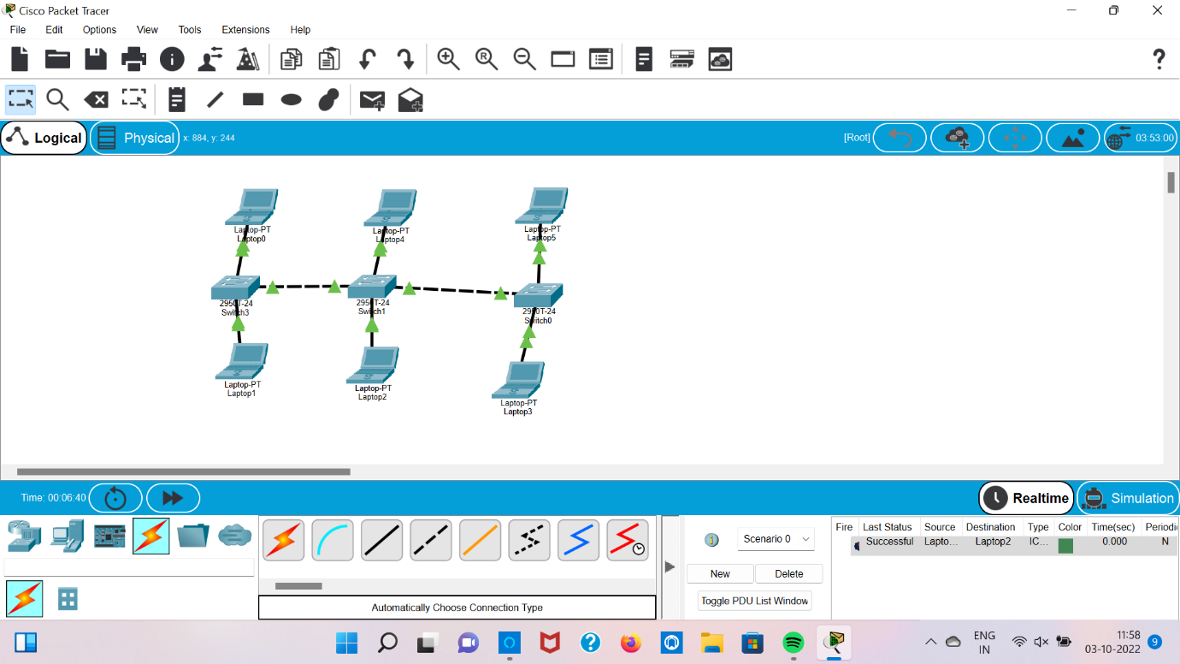

2.Configuration of Topologies using Packet Tracer (Star, Mesh, Tree,)

STAR

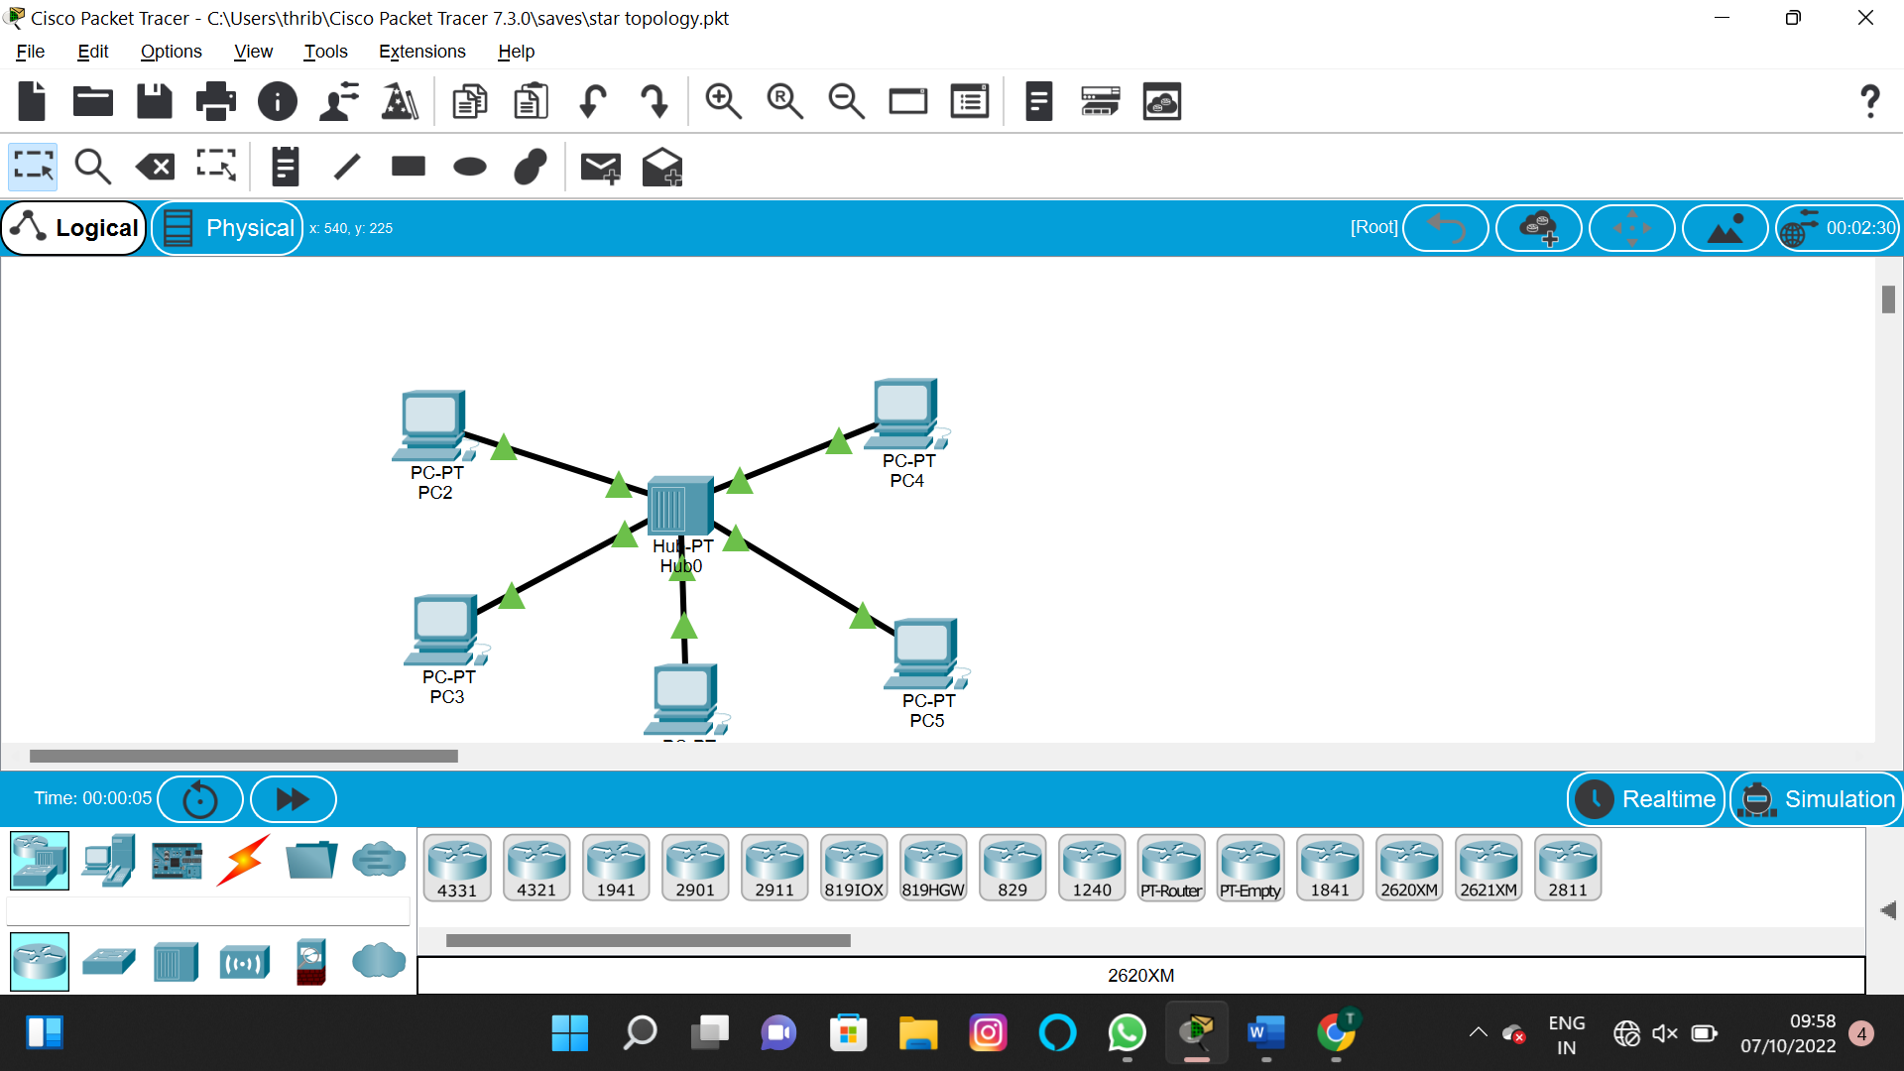

MESH

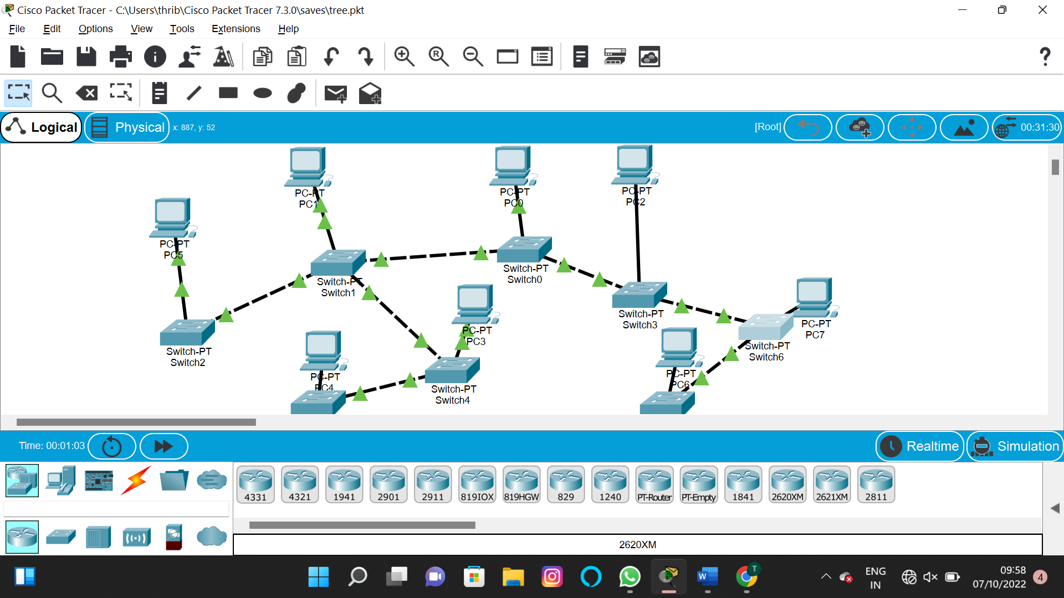

TREE

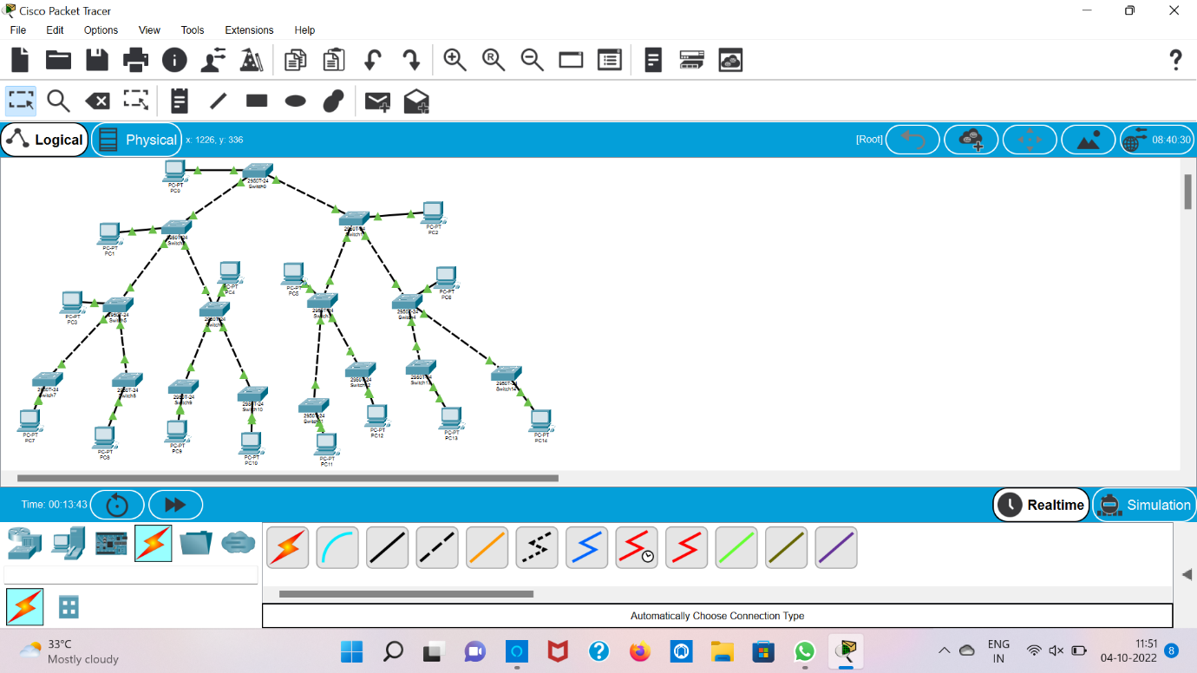

3.Configuration of Topologies using Packet Tracer (Bus, Ring, Hybrid)

BUS



RING

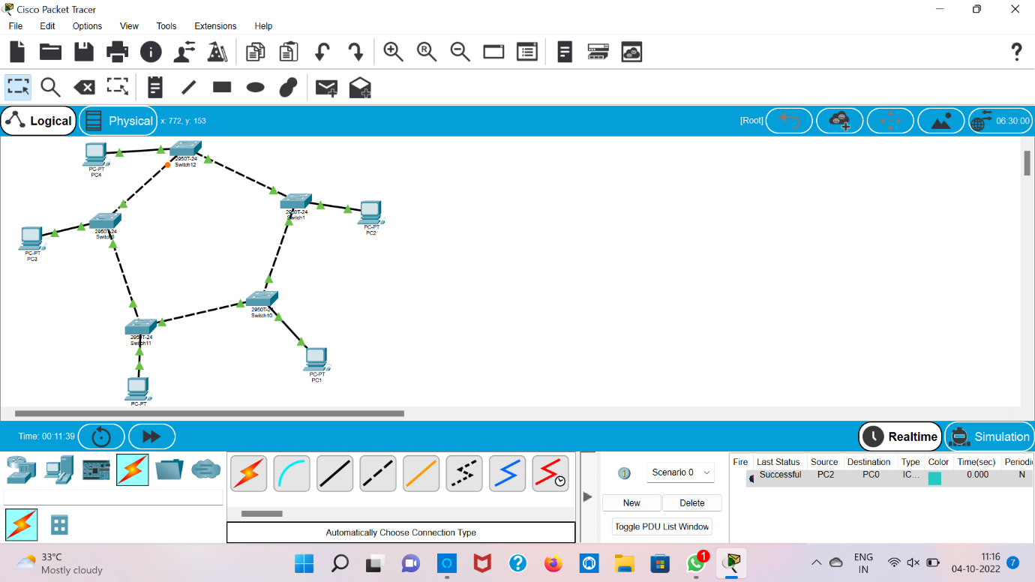

MESH

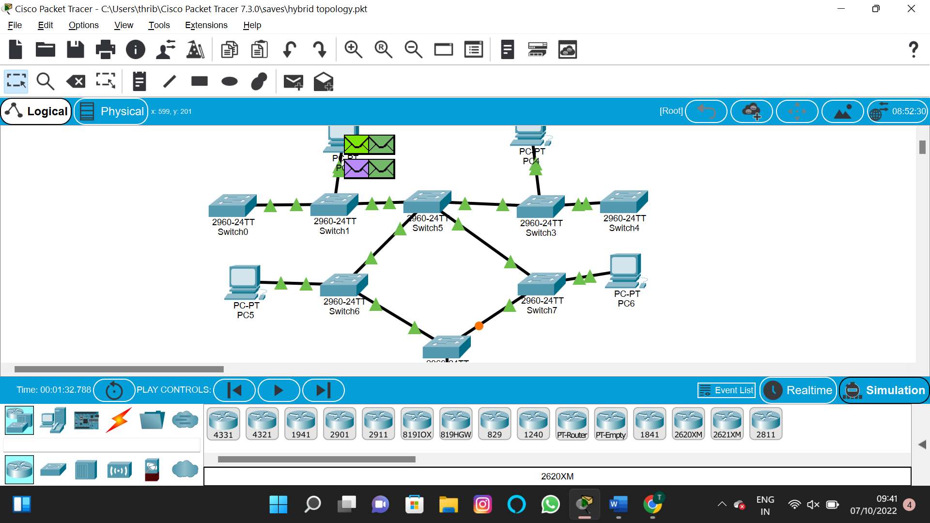

4.Data Link Layer Traffic Simulation using Packet Tracer Analysis of CSMA/CD& CSMA/CA

CSMA/CD&CSMA/CA

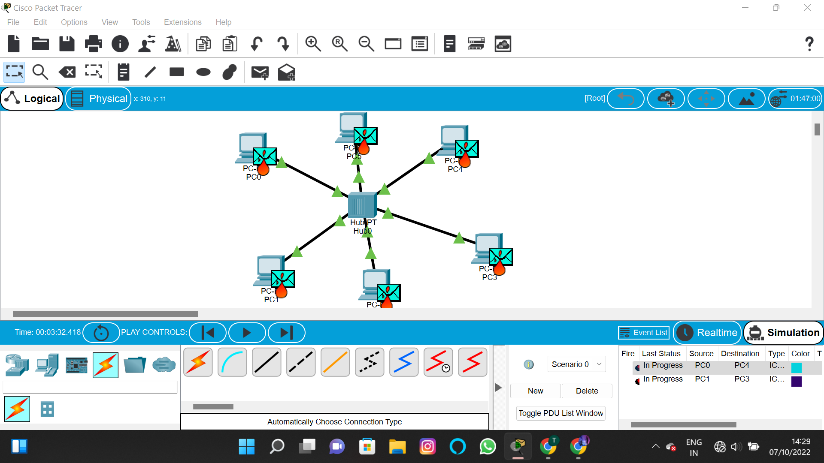

5.Data Link Layer Traffic Simulation using Packet Tracer Analysis of ARP

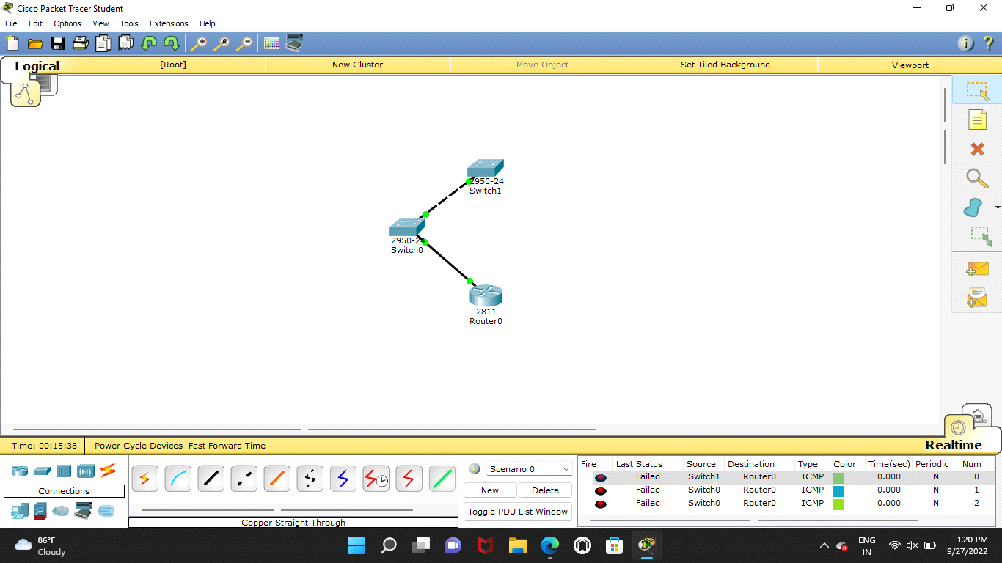

6.Static Routing using Packet Tracer

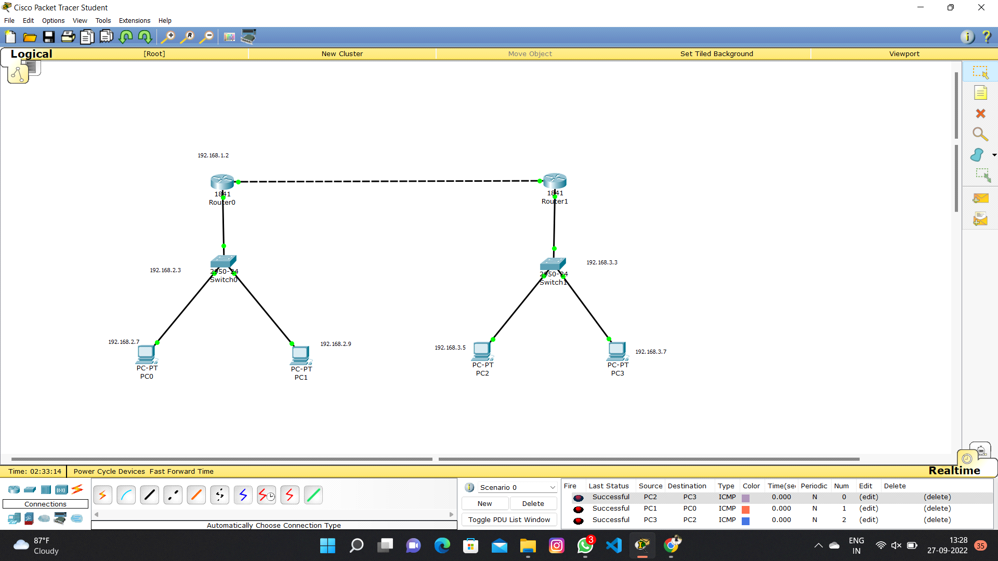

7.Dynamic Routing using Packet Tracer ( OSPF)

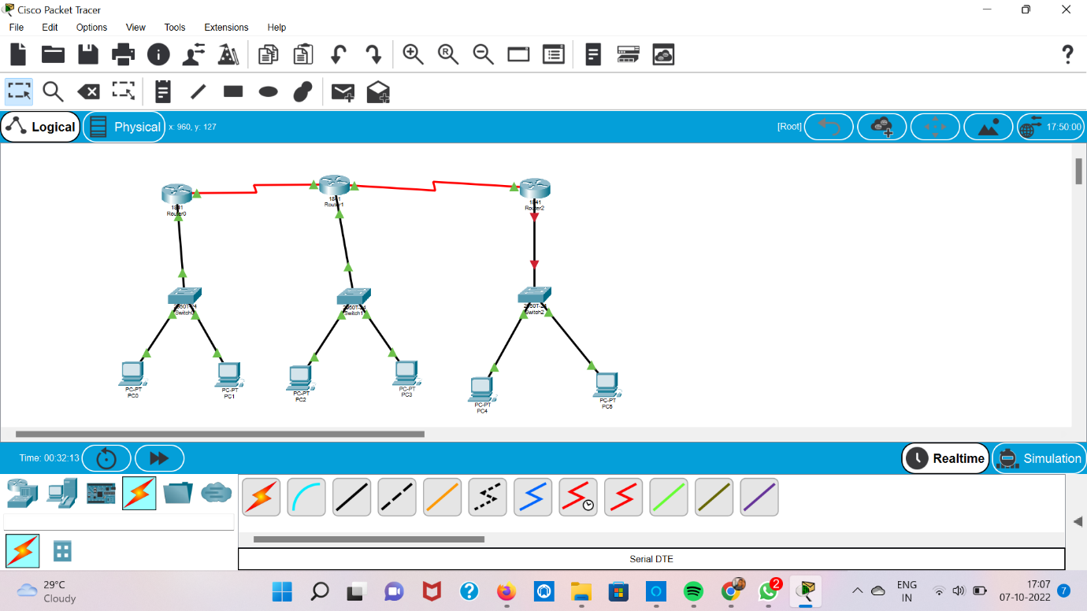

8.Subnetting – Class C Addressing

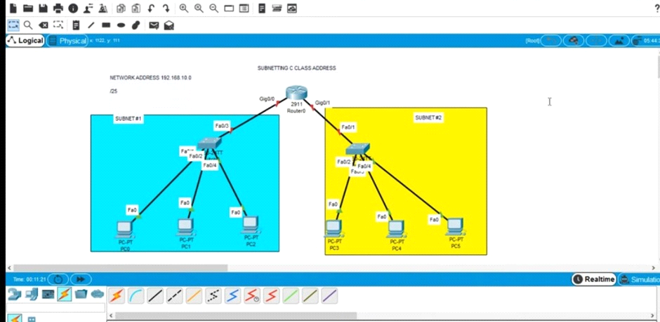

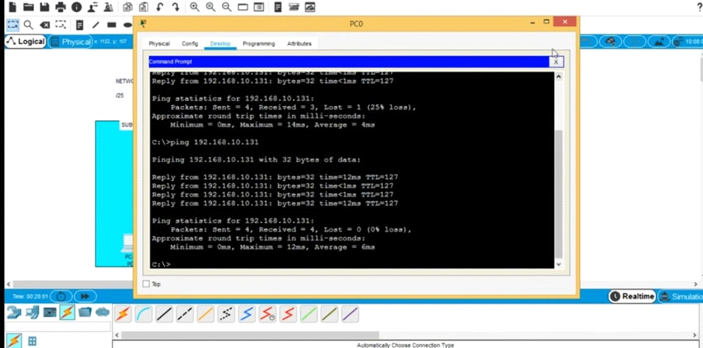

9.Functionalities of TCP, UDP

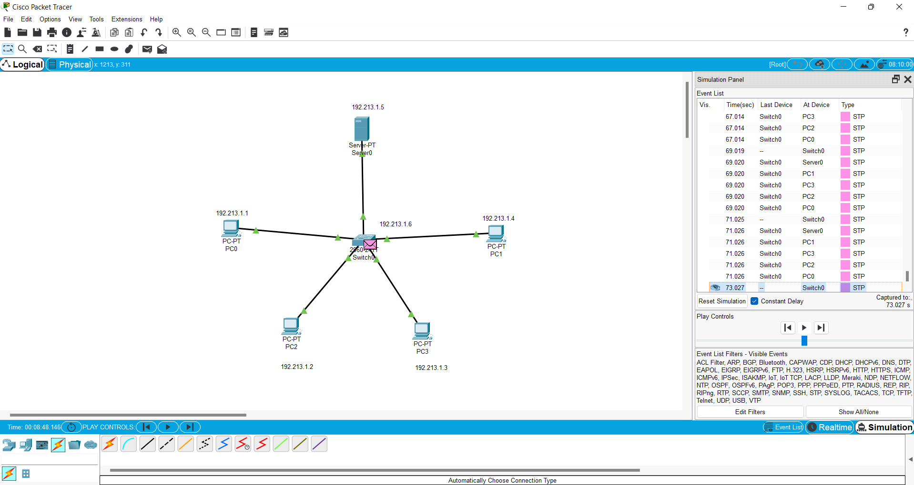

10.TCP, UDP Exploration Solution

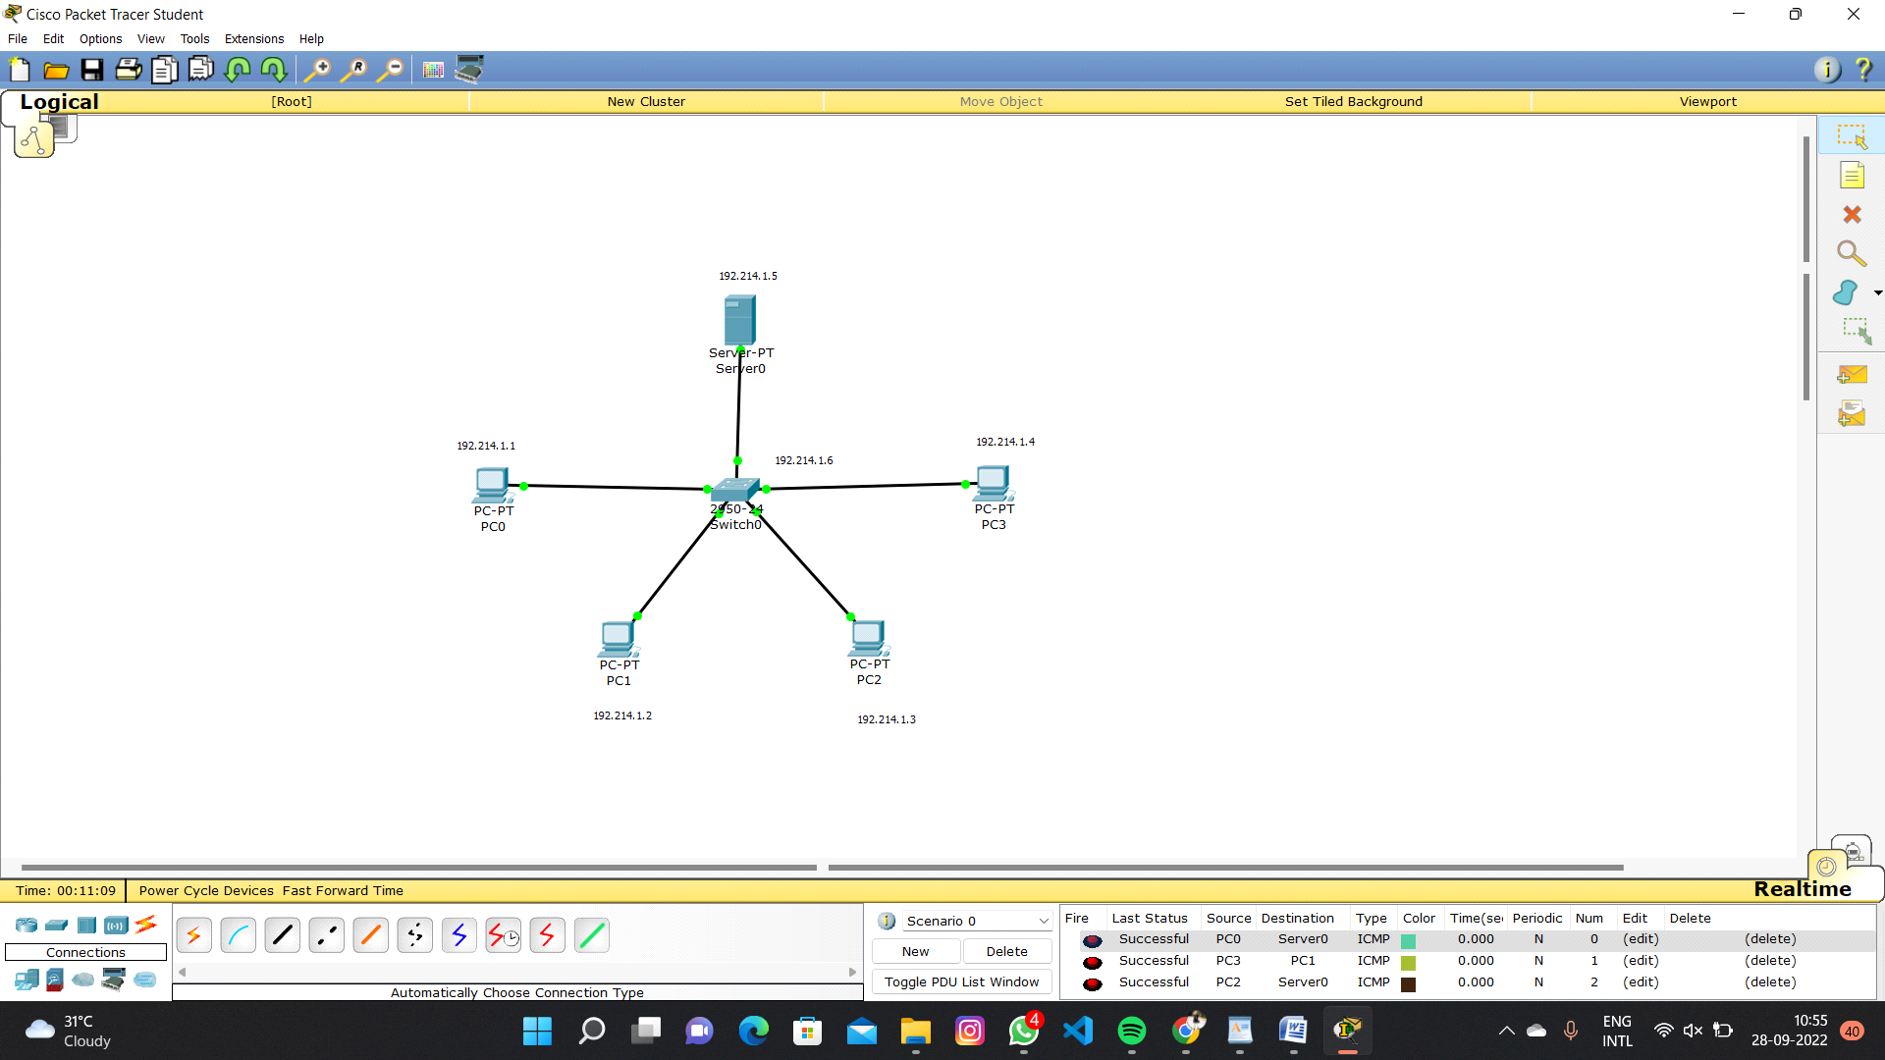

11.IOT Based Smart Home Using Cisco Packet Tracer

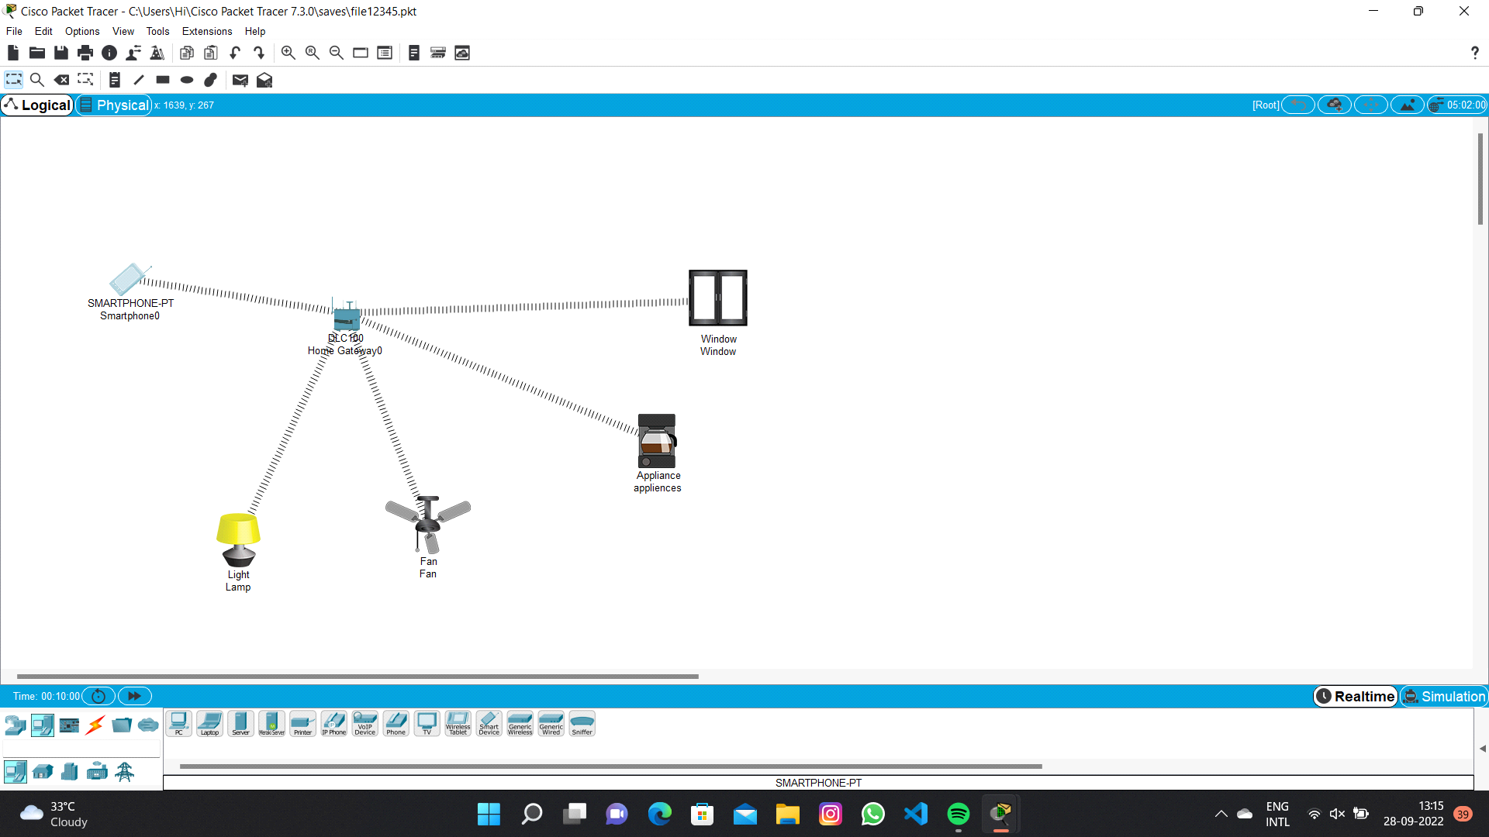

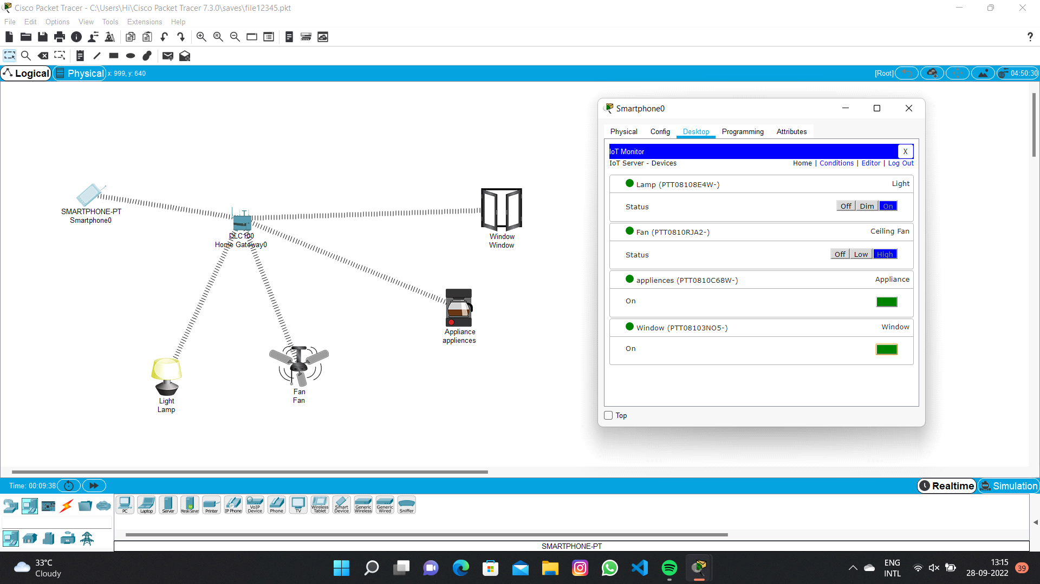

12.Smart Garden in Cisco Packet Tracer

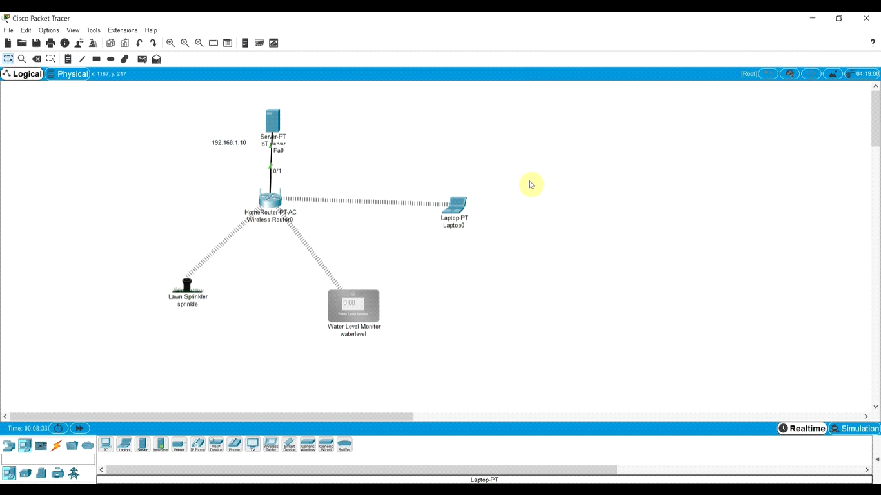

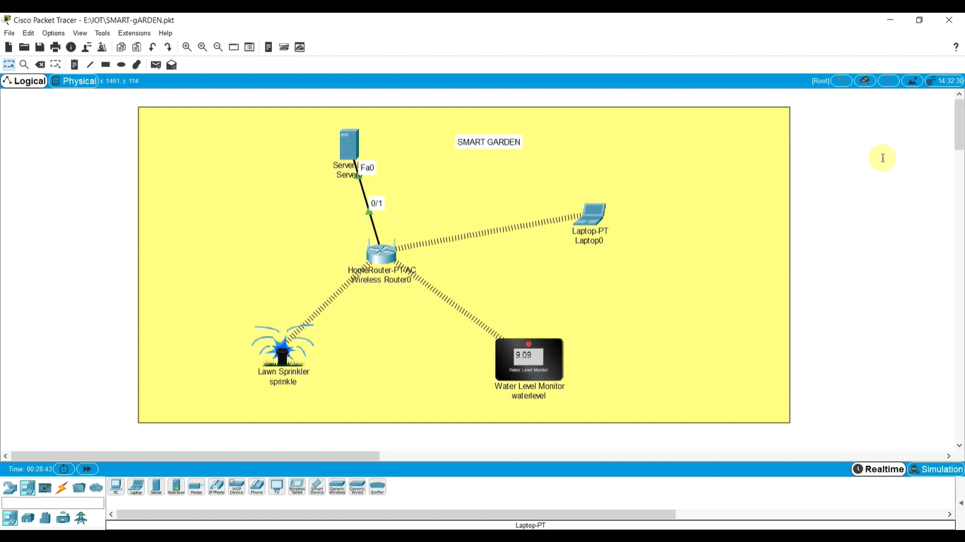

13.IOT Devices in Networking Using Cisco Packet Tracer

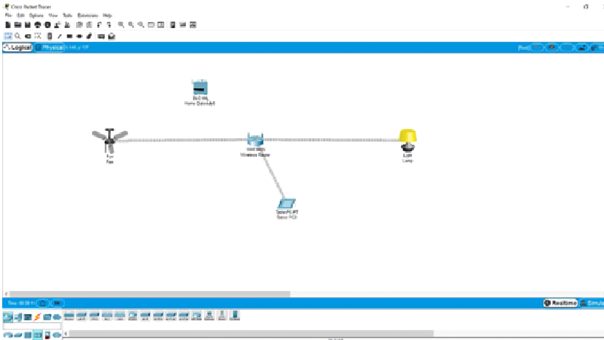

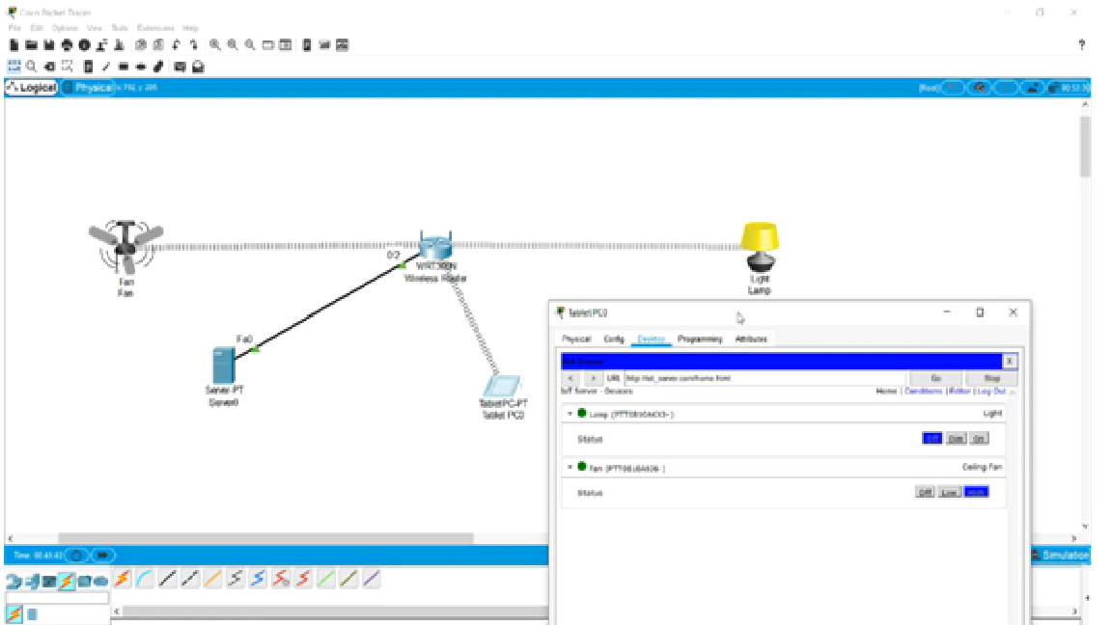

14.Simulating X,Y,Z Company Network Design

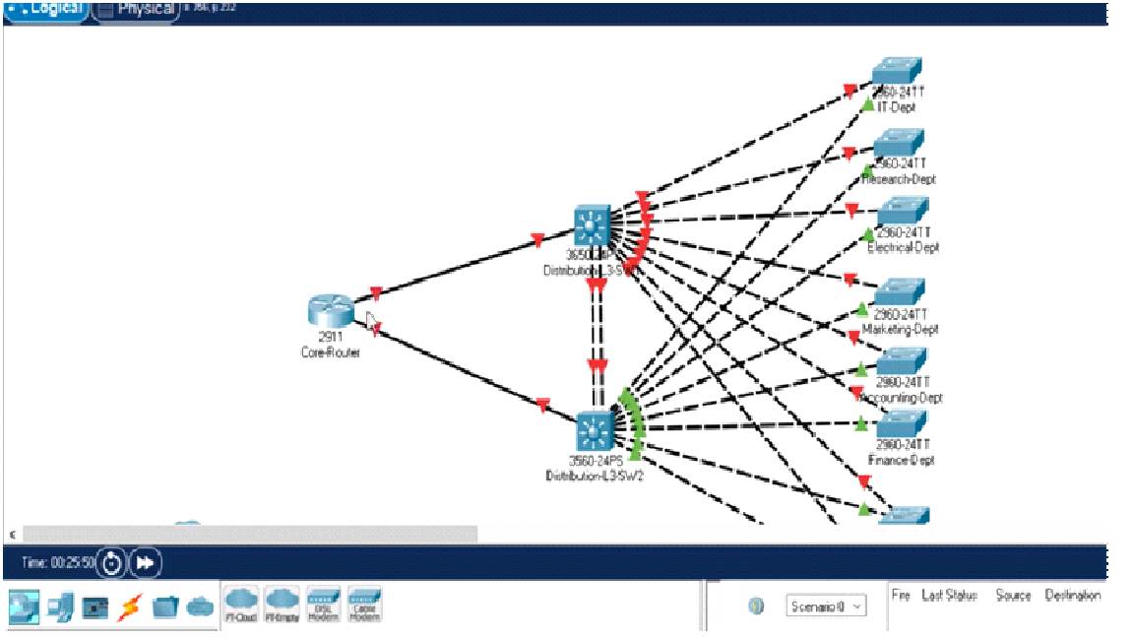

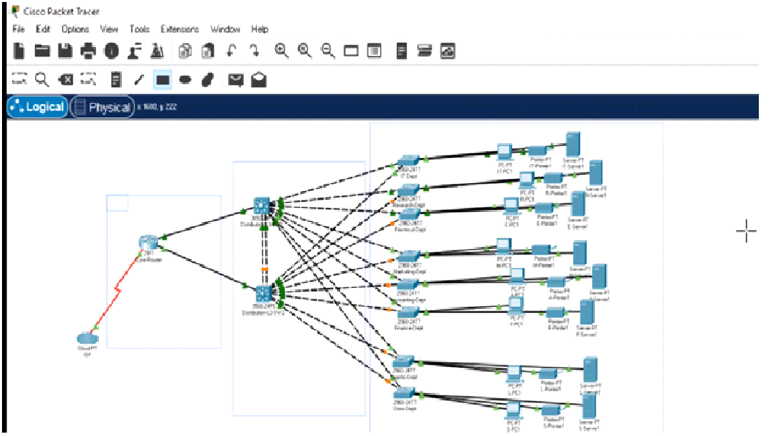

15.Make Computer Lab in Cisco Packet Tracer

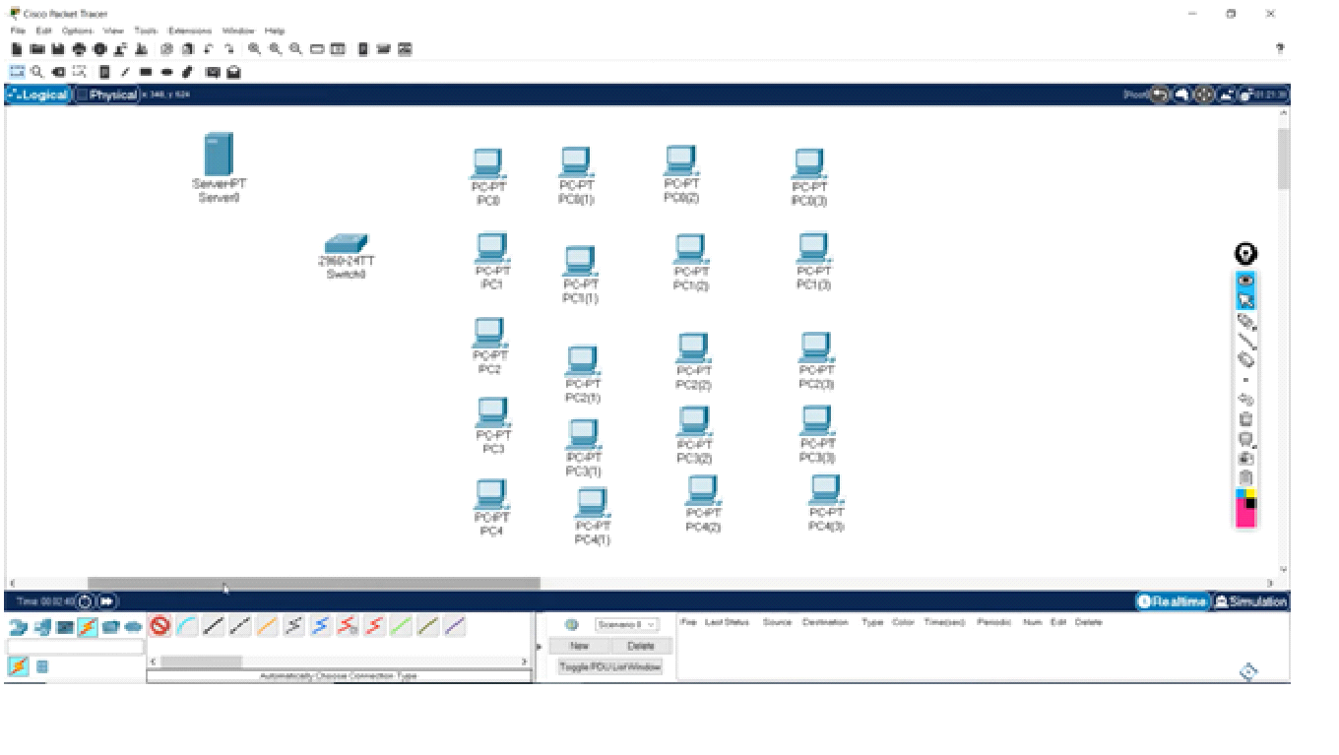

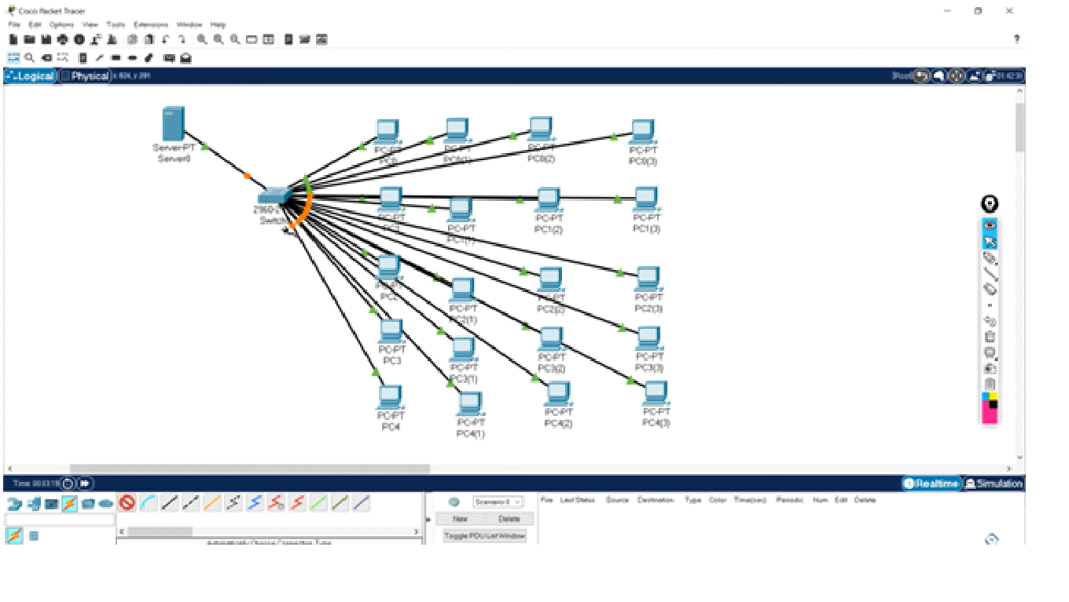

16.Simulate a Multimedia Network

19.WLAN Using Cisco Packet Tracer

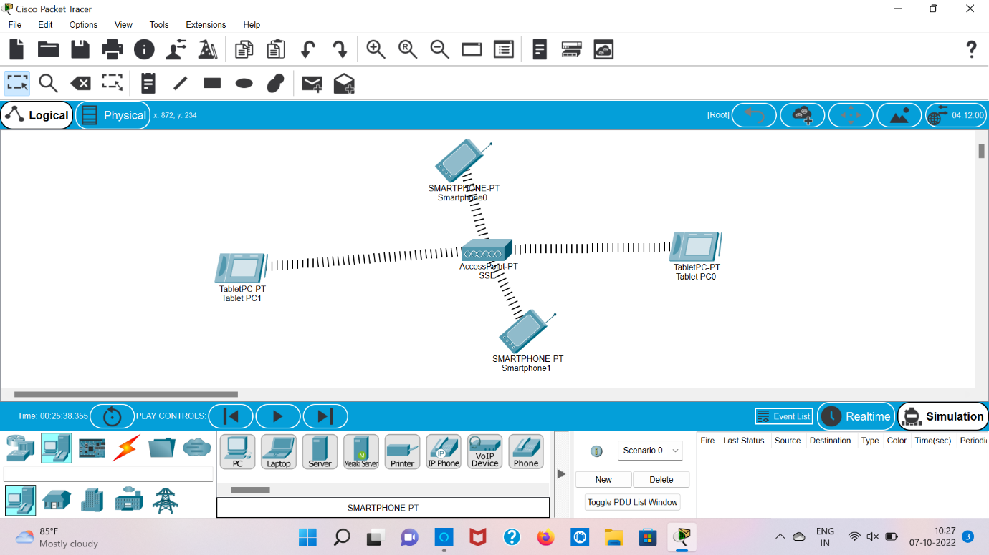

20.Control of Fan, Light, Window & Application of Using Cisco Packet Tracer

